**User Guidelines**

**After the application is run in your device you see the Home page where you see as shown in figure 1.**

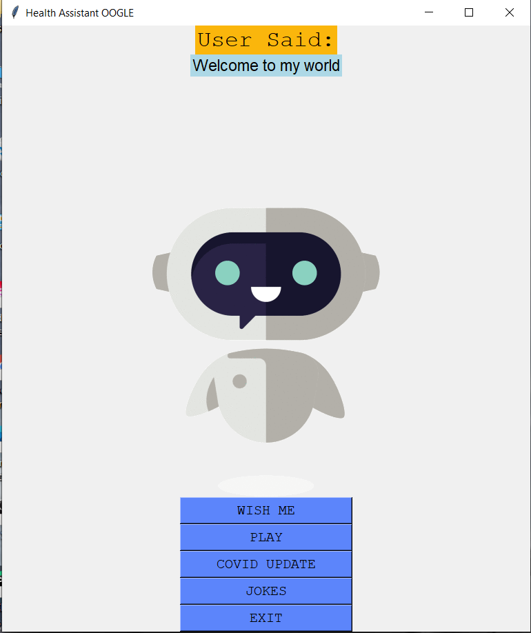

*Figure 1*

2. If you click the Covid Update button it will show you covid data, and then redirect to homepage as shown in figure 2.

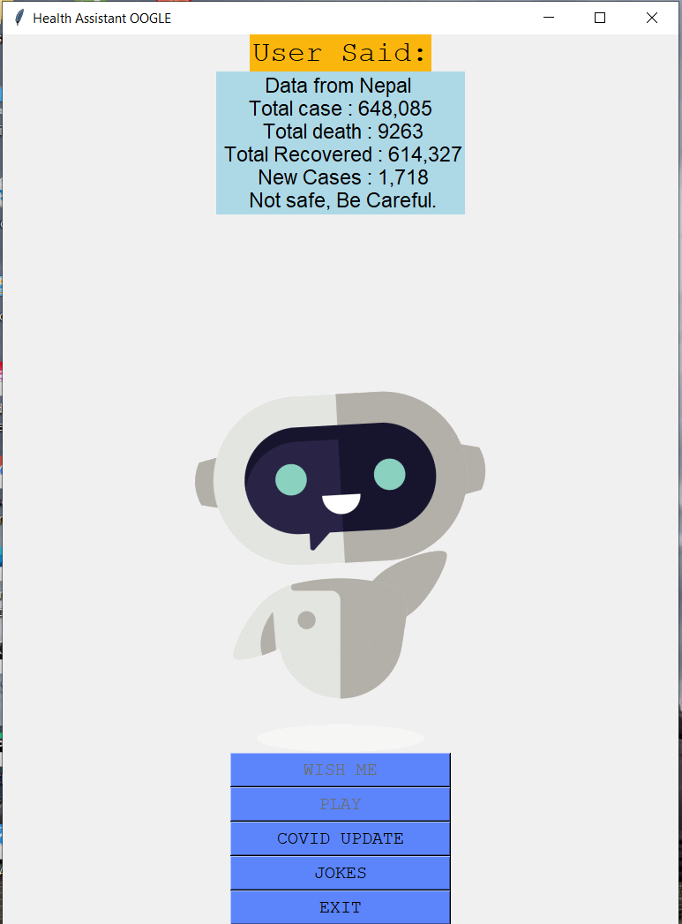

*Figure 2*

**3. If you click Joke button then you can hear one joke per one click, as shown in figure 3.**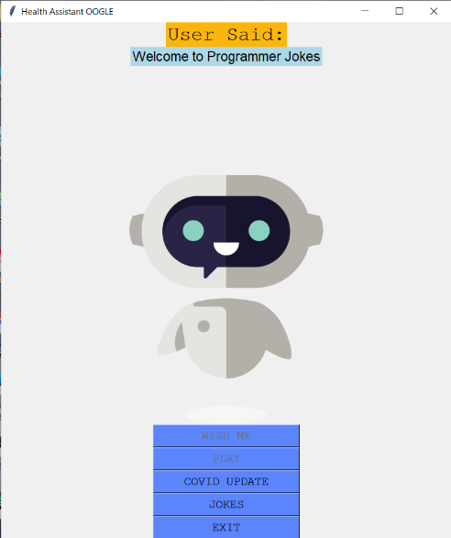

*Figure 3*

4. If you go through play button which is the Assistance waiting for your command, and you can see the results as shown in figures 4, 5 and 6.

*Figure 5*

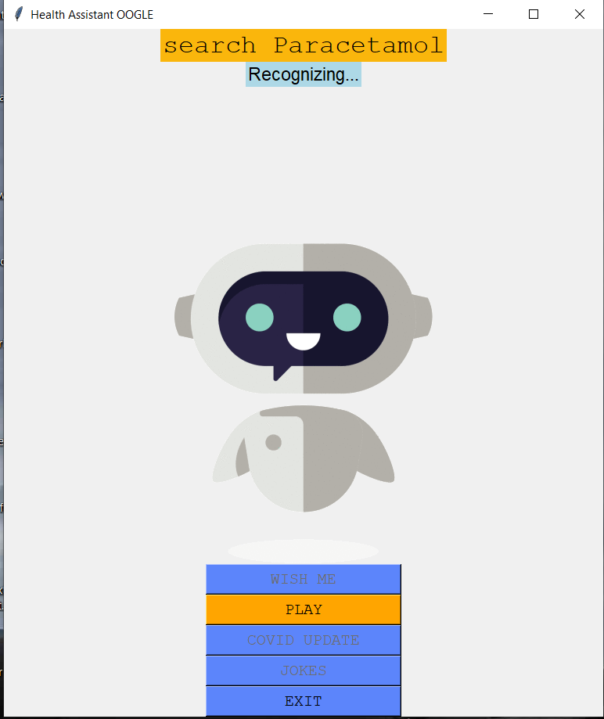

*Figure 4*

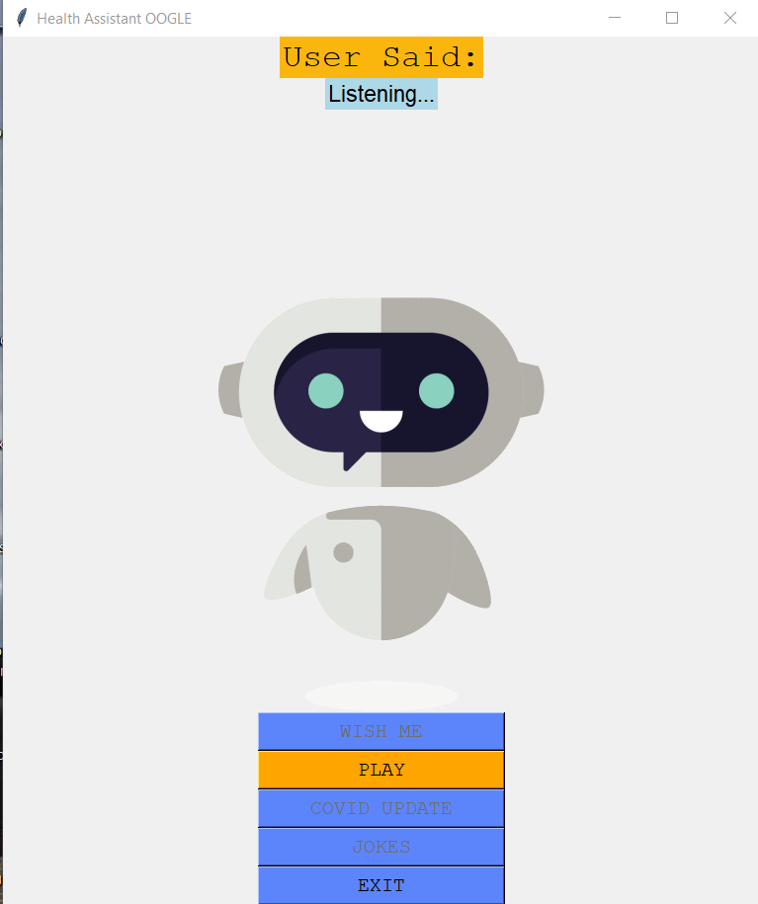

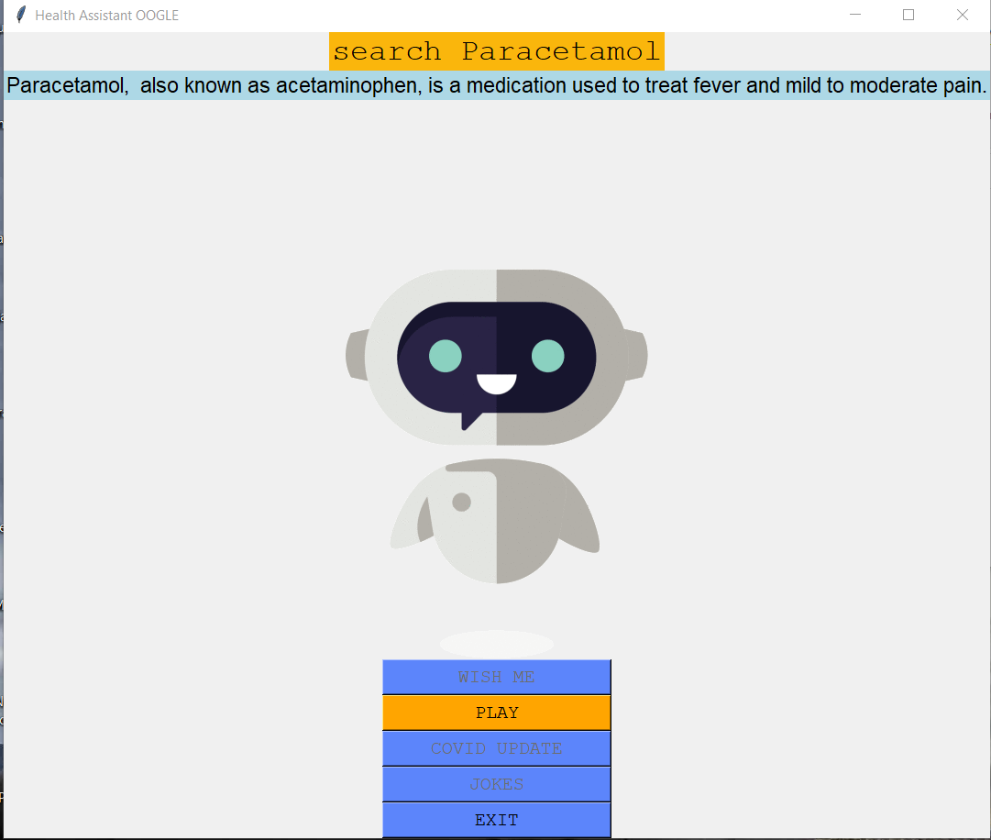

*Figure 6*

5.For to exit from program you must give command exit, and you will be shown as in figure 7.

